1 large book bag (no wheels): for carrying weekly folders and work between home and school. The book bag should be able to hold a 9.5” x 11.5” folder without the folder having to be bent in half. (This folder will be provided by the teacher and should last the whole year.) Please mark the bag with your child’s first and last name.
Change of Clothes: to be kept at school in case of an accident or spill (Please be sure to send underpants and socks, labeled with their first and last name).
12 Glue Sticks
1 box of #2 pencils Ticonderoga
1 box of Crayola washable markers (10 basic colors) FAT
2 boxes of 24 Crayola (skinny) crayons
1 container of Clorox Wipes
1 large box of Kleenex
1 bottle of hand sanitzer
1 box of sandwich-size ziplock bags
1 box of gallon-size ziplock bags
Lunch box: if your child brings lunch from home. Please make sure it is marked with his/her name and teacher’s name. (Also, please note that glass containers are not allowed due to safety concers.)
1 Regular Composition Notebook (wide-ruled or college-ruled is OK)
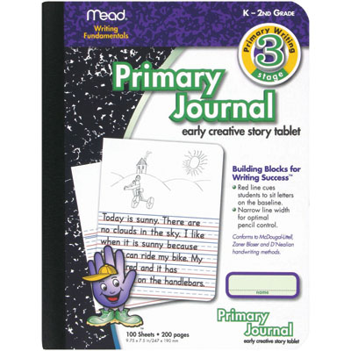
2 Primary Composition Notebooks (K-2): These have a blank box at the top and dotted lines below as shown in the picture. The cover may vary, but can be found at Wal-Mart, Target, Office Max, Office Depot, and Staples.

