4th Grade Supply List
2014-2015

General
- 1 pencil bag (Please no boxes!)
- One 1-inch binder (work portfolio)
- 1 box of pencils
- 1 glue stick
- 1 box of colored pencils
- 2 packs of wide-ruled loose-leaf paper
- 1 colored pen for checking work
- 1 Homework Folder (any color/design)
- Scissors
- Girls bring 1 box of Ziploc bags & 1 container of antibacterial wipes
- Boys bring 1 container of antibacterial wipes & 2 boxes of tissues
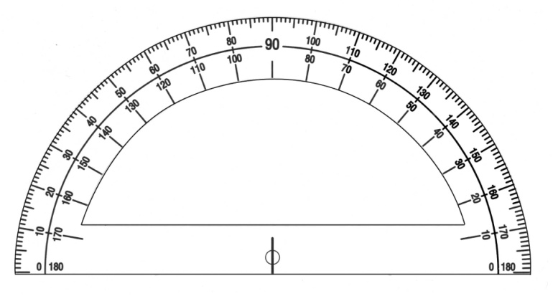

Math, Science, Social Studies
- One 2-inch binder (math)
- One pack of dividers (5 dividers/tabs)
- One 3-subject spiral (math)
- Two 1-subject spirals (math)
- One 3-subject spiral (science & SS)
- 1 protractor (no arm; shows the degrees above and below—see example)
- 1 pack of Expo dry erase markers (at least 2)

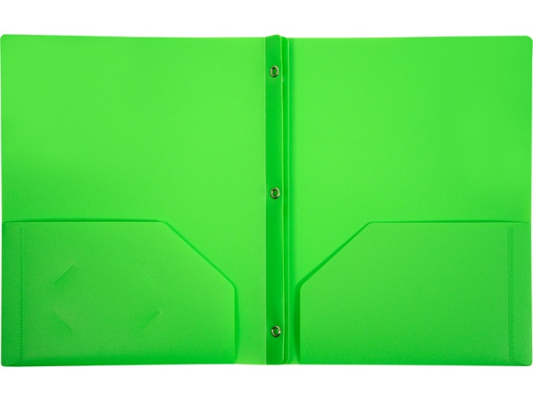
English Language Arts
- 2 packs of sticky notes
- Two Composition books
- 1 blue folder with pockets and brads for reading
- 1 green folder with pockets and brads for writing

Wish List
- Extra Expo Markers
- Mr. Sketch Markers (teacher use!)
- Sharpie Markers
- Extra Sticky Notes
- Board Magnets
- Electric Pencil Sharpener (for class)
- Indoor Recess Games (board games)
- Outdoor Recess Equipment (balls, etc.)

